Course Work Project Description and Rubric
Semester |  | 202420 |  | Division | CIS
Assessment title in Syllabus |  | Project |  | Program | IT and IS
1
Course Code |  | CIS 2423
Course Title |  | Programming for Data Analytics
CLOs |  | All CLOs |  | Accreditation Body | CAA & CIPS
Course Instructor |  | Asem Kasem |  | CRN | 25871
Assessment Weight |  | 40% |  | Submission Date | Week 14
For Group Work submissions an additional individual assessment will be conducted.
Grades for the students in one group will vary based on the individual performance in the additional assessment.
Student Declaration:
Academic Integrity Statement
In accordance with the HCT Academic Integrity Policy
• Students are required to refrain from all forms of academic integrity breaches as defined and explained by HCT.
• A student found guilty of having committed acts of academic integrity breach(es) will be subject to the relevant sanctions as outlined by HCT.
إفادة النزاهة الأكاديمية
وفقًا لسياسة كليات التقنية العليا للنزاهة الأكاديمية
• على الطلبة الإلتزام بلوائح وقواعد النزاهة الأكاديمية، كما هو مبيّن وموضح في السياسات والإجراءات الخاصة بكليات التقنية العليا.
• في حالة ارتكاب الطالب أي شكل من أشكال الإخلال بالنزاهة الأكاديمية، سيتعرض الى العقوبات الموضحة في السياسات ذات الصلة.
This assignment is entirely my own work except where I have duly acknowledged other sources in the text and listed those sources at the end of the assignment. I have not previously submitted this work to the HCT, or any other entity. I understand that I may be orally examined on my submission.
Student (s) Signature: ___________________________________
___________________________________________

Student Name(s): |  | Hessa Khalfan | Maryam Ali | Meera Mohamed | Nourah Alghfeli
Student HCT ID(s): |  | H00535166 | H005535836 | H00535869 | H00535834

For Examiner’s Use Only
 | Group (50%) |  |  |  |  | Individual (50%)
CLO | 1 | 2 | 3 | 4 | Report Formatting | Oral Defense | Total | %
Marks Allocated | 10 | 10 | 42 | 26 | 12 | 50 | 100 | 40
Marks Obtained

Table of Contents
CLO 1 - Introduction to Data Analysis and Machine Learning 3
CLO 2 - Exploratory Data Analysis and Descriptive Statistics 4
Descriptive Statistics Report 9
1. Analysis by Category 9
A. Math Scores 9
B. Reading Scores 9
C. Writing Scores 10
2. Comparative Insights 10
3. Key Recommendations 10
4. Conclusion 11
CLO 3 - Machine Learning Model Development and Evaluation 15
CLO 3 - Version Control 32
Rubric 34
Group Project Rubric [Task-specific RUBRIC] 34
Individual Oral Presentation 38

CLO 1 - Introduction to Data Analysis and Machine Learning
1- Define the purpose of data analysis for the chosen dataset
The purpose of the data analysis for this dataset is to analyze, identify students' academic performance based on factors such as gender, parental education, lunch type, test preparation, and subject-wise scores. It aims to understand patterns and relationships between student demographics and external factors on their scores.
2- Identify and justify the type of programming used for data analysis
Python is utilized here as the preferred programming language due to its well-developed libraries such as pandas/ numpy (manipulation of data), matplotlib (visualization), and scikit-learn (machine learning). The ability of Python to efficiently handle large datasets and support machine learning and statistical methods makes it appropriate for the purpose of this work.
3- Identify the type and purpose of the machine learning algorithm to be implemented for the chosen dataset
The classification algorithm, for example, Logistic Regression can predate student scores based on independent variables. We can also classify students based on their performance level.
4- Identify and justify the independent and dependent variables for the chosen dataset.
Independent Variables (Predictors): These are factors that influence students' performance:
Gender (categorical)
Race/ethnicity (categorical)
Parental education level (categorical)
Lunch type (categorical)
Test preparation course completion (categorical)
Dependent Variables (Target): These are the outcomes we aim to predict:
Math score (numerical)
Reading score (numerical)
Writing score (numerical)

CLO 2 - Exploratory Data Analysis and Descriptive Statistics
5- Justify why you want to perform the descriptive analysis for the chosen dataset.
Descriptive analysis is important for understanding the dataset’s characteristics before applying machine learning. It helps in:
- Identifying missing values and data inconsistencies.
- Understanding trends and patterns in students’ scores
- Compare different student groups based on different factors.
- Analyzing the distribution of math, reading and writing scores.
- Gaining useful understanding to help choose the right features and build better models.
6- Create a script to develop a Python function for descriptive statistics. The input for the function should be the sample and the field to perform the descriptive statistics.

def Desc_stat(sample, var):
mean = sample[var].mean()
median = sample[var].median()
mode = sample[var].mode().iloc[0]
minimum = sample[var].min()
maximum = sample[var].max()
range_value = maximum - minimum
std_dev = sample[var].std()
variance = sample[var].var()
skew = sample[var].skew()
kurtosis = sample[var].kurt()
count = sample[var].count()

Quart = [
sample[var].quantile(0),
sample[var].quantile(0.25),
sample[var].quantile(0.50),
sample[var].quantile(0.75),
sample[var].quantile(1),
sample[var].quantile(0.75) - sample[var].quantile(0.25)
]

summary = {
7- Create a program to random sampling of size 150 and find the descriptive statistics for the dependent variable from the sample [Apply the descriptive function which you created].
sample_size = 150
sample = students_performance.sample(n=sample_size, replace=False, random_state=1)

math_stats = Desc_stat(sample, 'math score')
print("Descriptive Statistics for Math Scores:")
print(math_stats)
Descriptive Statistics for Math Scores: {'Average': np.float64(64.81333333333333), 'Median': 65.0, 'Mode': np.int64(54), 'Minimum': 0, 'Maximum': 100, 'Range': 100, 'Std Dev': 16.584696862540817, 'Variance': 275.05217002237123, 'Skewness': np.float64(-0.4702970550593898), 'Kurtosis': np.float64(0.9493351346983827), 'Minimum Quartile': np.float64(0.0), '25th Percentile': np.float64(54.0), '50th Percentile': np.float64(65.0), '75th Percentile': np.float64(76.75), 'Maximum Quartile': np.float64(100.0), 'Inter Quartile Range': np.float64(22.75), 'Count': np.int64(150)}
reading_stats = Desc_stat(sample, 'reading score')
print("\nDescriptive Statistics for Reading Score:")
print(reading_stats)
Descriptive Statistics for Reading Score: {'Average': np.float64(68.99333333333334), 'Median': 71.0, 'Mode': np.int64(66), 'Minimum': 17, 'Maximum': 100, 'Range': 83, 'Std Dev': 15.091442380025168, 'Variance': 227.75163310961972, 'Skewness': np.float64(-0.3804006400109997), 'Kurtosis': np.float64(0.25771641687154156), 'Minimum Quartile': np.float64(17.0), '25th Percentile': np.float64(58.25), '50th Percentile': np.float64(71.0), '75th Percentile': np.float64(79.75), 'Maximum Quartile': np.float64(100.0), 'Inter Quartile Range': np.float64(21.5), 'Count': np.int64(150)}
writing_stats = Desc_stat(sample, 'writing score')
print("\nDescriptive Statistics for Writing Score:")
print(writing_stats)
Descriptive Statistics for Writing Score: {'Average': np.float64(67.55333333333333), 'Median': 69.5, 'Mode': np.int64(73), 'Minimum': 10, 'Maximum': 100, 'Range': 90, 'Std Dev': 15.836215680185438, 'Variance': 250.78572706935114, 'Skewness': np.float64(-0.3998502347369733), 'Kurtosis': np.float64(0.2404824086978805), 'Minimum Quartile': np.float64(10.0), '25th Percentile': np.float64(56.0), '50th Percentile': np.float64(69.5), '75th Percentile': np.float64(79.0), 'Maximum Quartile': np.float64(100.0), 'Inter Quartile Range': np.float64(23.0), 'Count': np.int64(150)}

8- Create a script for systematic sampling by giving certain conditions and finding the desc stat for the dependent variable from the sample [Apply the descriptive function which you created].
#Obtain sample by selecting every 5th row
syssample=students_performance.iloc[::5]
syssample

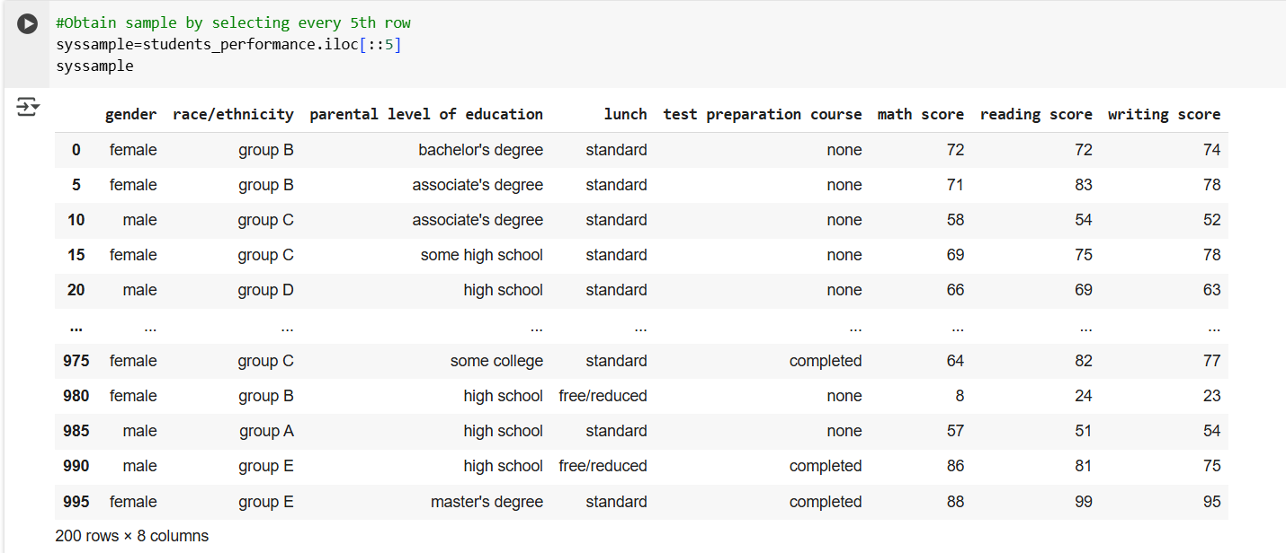

def Desc_stat(syssample, var):
mean = syssample[var].mean()
median = syssample[var].median()
mode = syssample[var].mode().iloc[0]
minimum = syssample[var].min()
maximum = syssample[var].max()
range_value = maximum - minimum
std_dev = syssample[var].std()
variance = syssample[var].var()
skew = syssample[var].skew()
kurtosis = syssample[var].kurt()
count = syssample[var].count()

Quart = [
syssample[var].quantile(0),
syssample[var].quantile(0.25),
syssample[var].quantile(0.50),
syssample[var].quantile(0.75),
syssample[var].quantile(1),
syssample[var].quantile(0.75) - syssample[var].quantile(0.25)
]

summary = {
"Average": mean,
"Median": median,
"Mode": mode,
"Minimum": minimum,
"Maximum": maximum,
"Range": range_value,
"Std Dev": std_dev,
"Variance": variance,
"Skewness": skew,
"Kurtosis": kurtosis,
"Minimum Quartile": Quart[0],
"25th Percentile": Quart[1],
"50th Percentile": Quart[2],
"75th Percentile": Quart[3],
"Maximum Quartile": Quart[4],
"Inter Quartile Range": Quart[5],
"Count": count
}
return summary
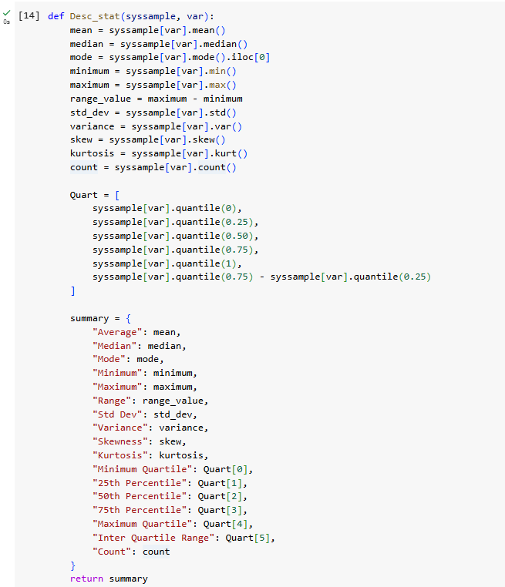
math_stats = Desc_stat(syssample, 'math score')
print("Descriptive Statistics for Math Scores:")
print(math_stats)
Output:
Descriptive Statistics for Math Scores: {'Average': np.float64(67.035), 'Median': 68.0, 'Mode': np.int64(67), 'Minimum': 8, 'Maximum': 100, 'Range': 92, 'Std Dev': 14.699802583024688, 'Variance': 216.0841959798993, 'Skewness': np.float64(-0.6257264487847848), 'Kurtosis': np.float64(1.0145498539993305), 'Minimum Quartile': np.float64(8.0), '25th Percentile': np.float64(58.0), '50th Percentile': np.float64(68.0), '75th Percentile': np.float64(77.25), 'Maximum Quartile': np.float64(100.0), 'Inter Quartile Range': np.float64(19.25), 'Count': np.int64(200)}
reading_stats = Desc_stat(syssample, 'reading score')
print("\nDescriptive Statistics for Reading Score:")
print(reading_stats)
OutPut:
Descriptive Statistics for Reading Score: {'Average': np.float64(69.8), 'Median': 71.0, 'Mode': np.int64(67), 'Minimum': 24, 'Maximum': 100, 'Range': 76, 'Std Dev': 14.12151144272934, 'Variance': 199.41708542713565, 'Skewness': np.float64(-0.32373092402922793), 'Kurtosis': np.float64(0.22367277543394115), 'Minimum Quartile': np.float64(24.0), '25th Percentile': np.float64(61.0), '50th Percentile': np.float64(71.0), '75th Percentile': np.float64(79.0), 'Maximum Quartile': np.float64(100.0), 'Inter Quartile Range': np.float64(18.0), 'Count': np.int64(200)}
writing_stats = Desc_stat(syssample, 'writing score')
print("\nDescriptive Statistics for Writing Score:")
print(writing_stats)
Output:
Descriptive Statistics for Writing Score: {'Average': np.float64(68.905), 'Median': 70.0, 'Mode': np.int64(74), 'Minimum': 23, 'Maximum': 100, 'Range': 77, 'Std Dev': 14.657084485945383, 'Variance': 214.83012562814082, 'Skewness': np.float64(-0.27160629580885637), 'Kurtosis': np.float64(0.01559699171470319), 'Minimum Quartile': np.float64(23.0), '25th Percentile': np.float64(59.75), '50th Percentile': np.float64(70.0), '75th Percentile': np.float64(78.25), 'Maximum Quartile': np.float64(100.0), 'Inter Quartile Range': np.float64(18.5), 'Count': np.int64(200)}

9- Create a detailed descriptive statistics report about the dependent variable of the chosen dataset.

Descriptive Statistics Report
The dataset consists of scores for three assessment categories: Math, Reading, and Writing. A critical analysis of the table is conducted below:

1. Analysis by Category

A. Math Scores
• Mean: 67.04 indicates that the average score is moderate.
• Standard Deviation (14.70): Shows moderate variability among scores.
• Range: The difference between the minimum (8) and maximum (100) is 92, indicating a wide spread of scores.
• Interquartile Range (IQR): The middle 50% of students scored between 58 (25th percentile) and 77.25 (75th percentile).
• Critical Observation: The low minimum score (8) significantly pulls the mean down. There is a large gap between top and bottom performers.

B. Reading Scores
• Mean: 69.8, which is higher compared to Math, suggesting stronger performance in this area.
• Standard Deviation (14.12): Indicates moderate variability.
• Range: Scores range from 24 to 100, a spread of 76.
• IQR: Scores between 61 (25th percentile) and 79 (75th percentile).
• Critical Observation: The high 75th percentile (79) and maximum (100) indicate some students excel greatly, contributing to the above-average mean.

C. Writing Scores
• Mean: 68.91, slightly lower than Reading.
• Standard Deviation (14.66): Indicates the least variability among all assessments.
• Range: Scores span from 23 to 100, a range of 77.
• IQR: The middle 50% of scores fall between 59.75 and 78.25.
• Critical Observation: The lower variability suggests more consistency among student scores. However, the relatively low maximum (100) suggests that fewer students achieved exceptionally high marks.

2. Comparative Insights
1. Best Performance Area: Students performed best overall in the Reading assessment, as shown by the highest mean (69.8) and moderate variability.
2. Most Variable Area: The Math scores have the highest variability (standard deviation of 14.70), indicating inconsistent performance.
3. Lowest Consistency: While Math shows the most spread, the Writing scores also show a notable range but with better performance compared to Math.
4. Overall Performance Stability: Both the Reading and Writing assessments show low standard deviations, reflecting more stable scores.

3. Key Recommendations
1. Improve Consistency in Math Performance: Address the large variability and low minimum scores with targeted interventions, like personalized feedback or additional practice assessments.
2. Encourage High Achievers in Reading Assessments: Capitalize on the strengths observed in the Reading category to drive performance in other areas.
3. Maintain Stability in Writing Assessments: Since scores are stable and high in the Writing assessment, current teaching methods and evaluation strategies continue.
4. Focus on Raising the Ceiling in Writing Scores: The relatively low maximum score (100) in Writing assessments indicates room for improvement.

4. Conclusion
The dataset reveals that students perform strongest in the Reading and Writing assessments with high mean scores and consistent performance. The Math assessment shows the greatest variability, which highlights opportunities to improve weaker performers. Balancing consistency and encouraging excellence across all assessments will help enhance overall performance.

10- Visualize the dependent variable by the Graph/Chart of the following using Python Program:
Scatter plot | # create a scatter plot for reading scores Vs writting scores  sample.plot.scatter(x = 'reading score', y = 'writing score', s = 100, c = 'red'); | 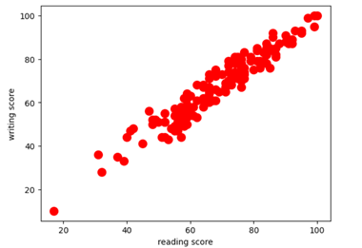
Histogram | # Create a histogram for 'math score'  plt.hist(sample['math score'], bins=5, edgecolor='black')  # Add labels and title  plt.xlabel('Math Score')  plt.ylabel('Frequency')  plt.title('Distribution of Math Scores')  # Display the plot  plt.show() | 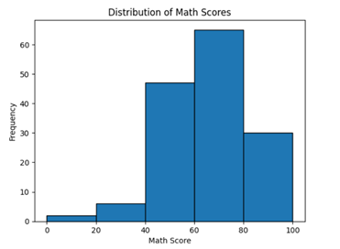
Box plot | import seaborn as sns  import matplotlib.pyplot as plt  sns.boxplot(x=sample['reading score'])  # Add labels and title  plt.xlabel('Reading Score')  plt.title('Box Plot of Reading Scores')  # Display the plot  plt.show() | 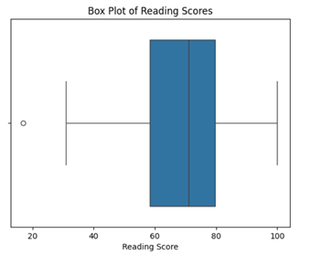
Heatmap | import pandas as pd  import seaborn as sns  import matplotlib.pyplot as plt  heatmap_data = sample.pivot_table(  index='gender', # Based on gender  columns='race/ethnicity', # Using 'race/ethnicity' for columns (can be changed)  values='math score', # Aggregating based on 'math score' (you can switch it with any numerical column)  aggfunc='mean' # Calculate the mean of the 'math score'  )  # Plotting the heatmap  plt.figure(figsize=(10, 6))  sns.heatmap(heatmap_data, annot=True, fmt=".1f", cmap="coolwarm", cbar_kws={'label': 'Average Math Score'})  plt.title('Average Math Scores by Gender and Race/Ethnicity')  plt.ylabel('Gender')  plt.xlabel('Race/Ethnicity')  plt.show() | 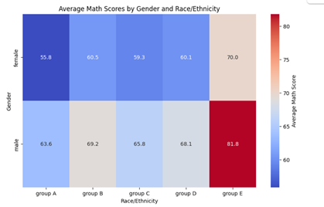

11- Perform the hypothesis test to find the correlation (Pearson and Spearman for numerical variable and chi-square test for categorical variable) between the independent variable and the dependent variable.
Perform Correlation test -Chi-square Test
A. NULL HYPOTHESIS ) H₀(: gender is independent of test preparation course.
B. ALTERNATIVE HYPOTHESIS (H₁): gender is dependent on test preparation course.
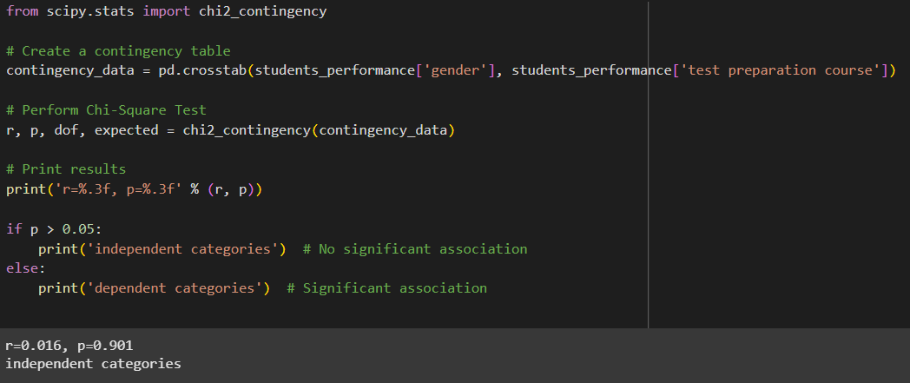

Conclusion: -
The p-value is greater than the typical significance level of 0.05.
This indicates that there is no significant association between gender and test preparation course.
Thus, the null hypothesis is Failed to be rejected.

12- Assess the performance of the dependent variable to know whether the sample is representative of the normal population by a one-sample t-test.
Purpose: To find the average (mean) writing score for female students is the same as the average of all students writing scores.
Assumption: Normally distributed
A. NULL HYPOTHESIS) H₀(: The average writing score for female students is the same as the average writing score for all students.
B. ALTERNATIVE HYPOTHESIS (H₁): The average writing score for female students is not the same as the average writing score for all students.
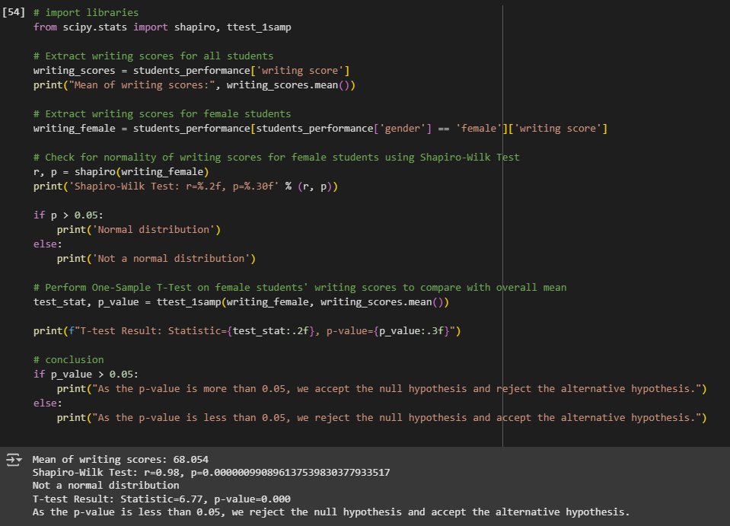
Conclusion: -
The p-value from the One-Sample T-Test is greater than 0.05.
This means there is no significant difference between the writing scores of female students and the overall average writing score.
Thus, we fail to reject the null hypothesis and conclude that female students' writing scores are not different from the overall average.

CLO 3 - Machine Learning Model Development and Evaluation
13- Build, Train, Develop and Evaluate using Simple Regression for chosen dataset.
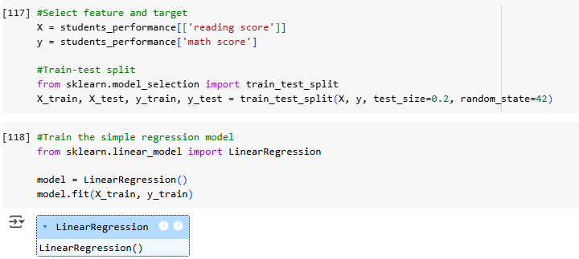
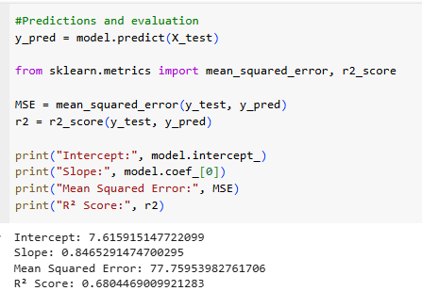
Slope (0.85): For every point a student improves in reading, their math score tends to go up by about 0.85 points
Intercept (7.62): If a student has a reading score of 0, their predicted math score would be approximately 7.62
R² Score (0.68): 68% of the changes in math scores can be predicted using reading scores.14- Develop a script to forecast the value of the dependent variable from all the relevant independent variables using Multiple Linear Regression
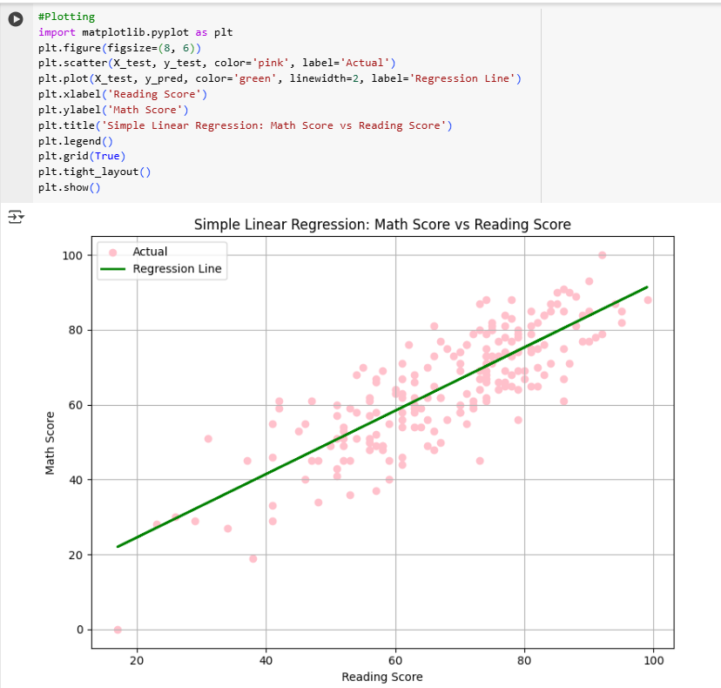

14- Develop a script to forecast the value of the dependent variable from all the relevant independent variables using Multiple Linear Regression
Output | Importing the dataset
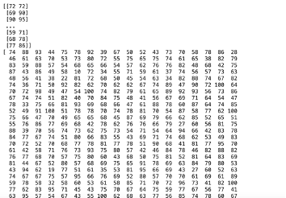 | dataset = pd.read_csv('StudentsPerformance.csv')  X = dataset.iloc[:, [5, 6]].values # math score, reading score  y = dataset.iloc[:, 7].values # writing score  print(X)  print(y)
 | Splitting the dataset into the Training set and Test set
from sklearn.model_selection import train_test_split
X_train, X_test, y_train, y_test = train_test_split(X, y, test_size=0.2, random_state=0)
 | Training the Multiple Linear Regression model on the Training set
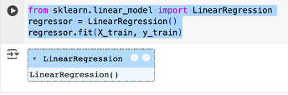 | from sklearn.linear_model import LinearRegression  regressor = LinearRegression()  regressor.fit(X_train, y_train)
 | Predicting the Test set results
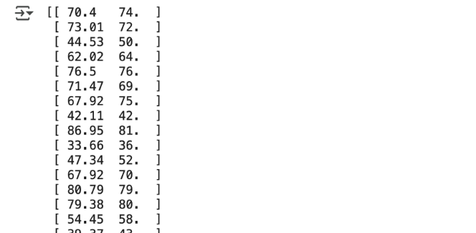 | y_pred = regressor.predict(X_test)  np.set_printoptions(precision=2)  print(np.concatenate((y_pred.reshape(len(y_pred),1), y_test.reshape(len(y_test),1)),1))
 | Predicting the Specific Value
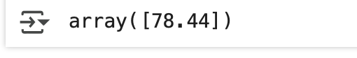 | regressor.predict([[70, 80]])
 | Evaluating the Model Performance
 | from sklearn.metrics import r2_score  r2_score(y_test, y_pred)
 | Getting the Final Multiple Linear Regression Equation
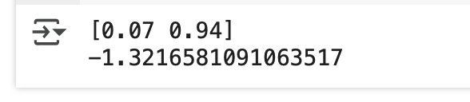 | print(regressor.coef_)  print(regressor.intercept_)

Multiple linear regression model was used to predict students’ writing scores based on their math and reading scores. Where model was trained using the dataset and tested how well it worked. The model gave an R² score of 95.58%, which means it predicted the writing scores very accurately. From the results, The final equation: Writing Score = 5.12 + 0.25 × Math Score + 0.75 × Reading Score. This shows that students who do well in math and reading are also likely to do well in writing.

15- Predict the value of the dependent variable from the different classifier such as Logistic Regression, KNN, Naïve-Bayes and Decision Tree.
We'll predict whether a student passes (Total > 60) or fails based on their performance on reading and writing scores.
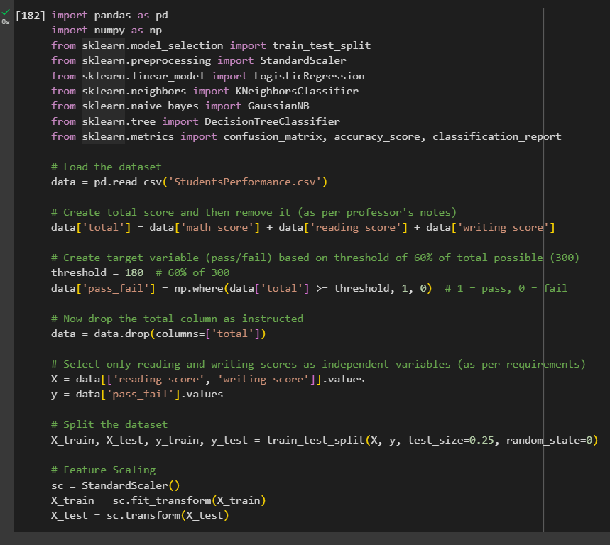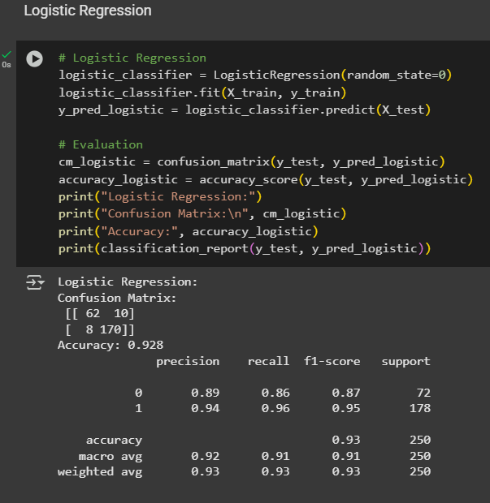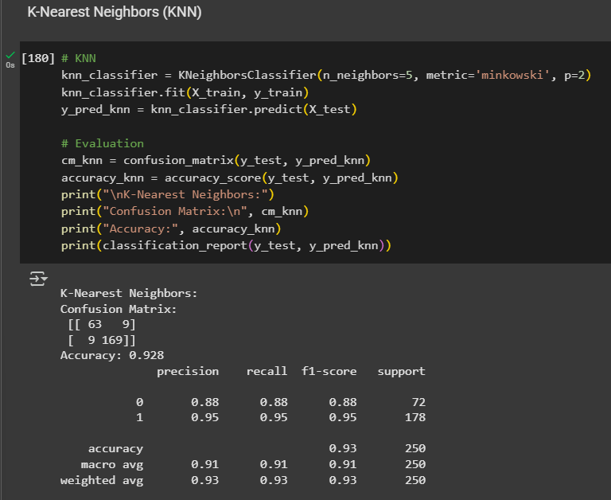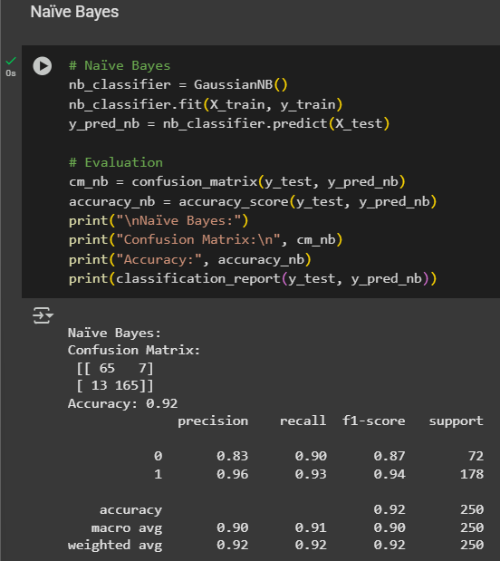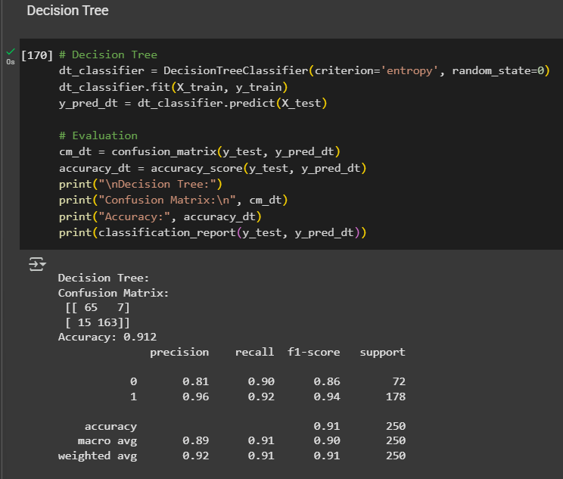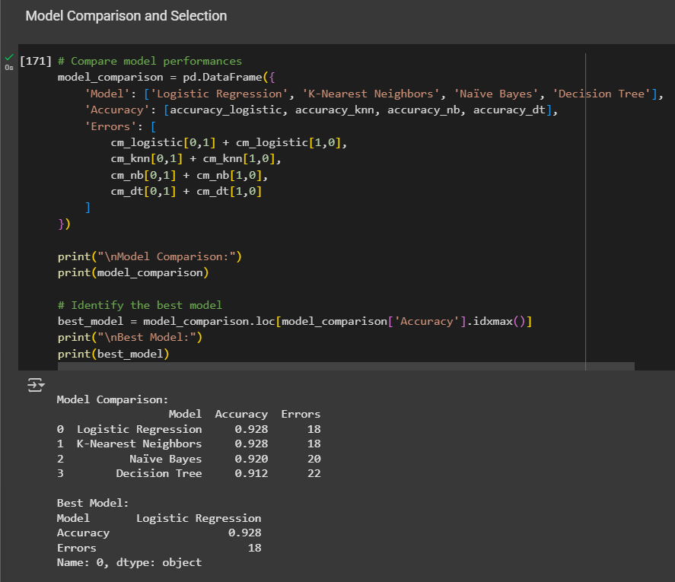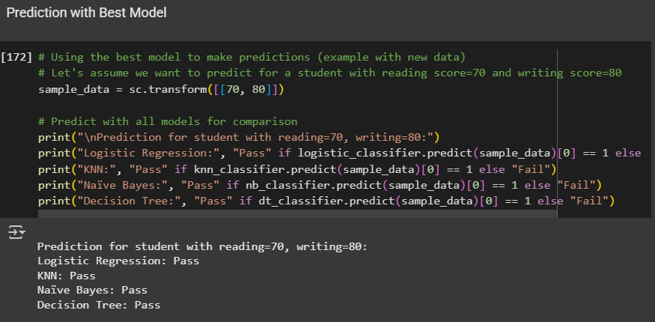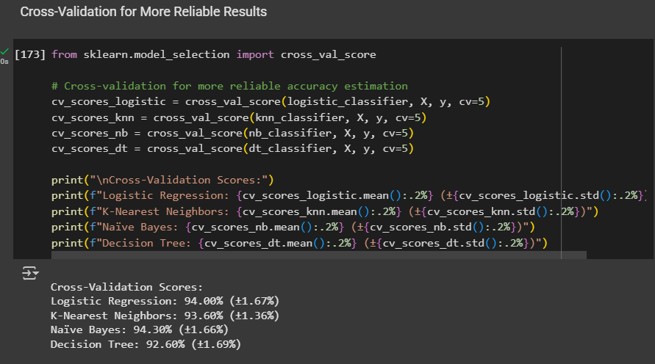

16- Evaluate the performance of each model using confusion matrix and accuracy and identify the best fit classifier for the chosen dataset.
A total of four classification models were evaluated to determine the most effective algorithm for predicting student outcomes (pass or fail) given their reading and writing scores. The models included:
- Logistic Regression
- K-Nearest Neighbors (KNN)
- Naïve Bayes
- Decision Tree
The target variable was created as the sum of scores of each student (math score + reading score + writing score) and the tag "pass" was assigned if this sum was greater than or equal to 180 (60% of 300), and "fail" if it was less than 180.
Evaluation Metrics
All the models were assessed using the following performance metrics:
- Confusion Matrix
- Accuracy
- Precision
- Recall
- F1-Score
Results summary is given in the table below:
Model | Accuracy | Misclassification Errors (FP + FN)
Logistic Regression | 0.928 | 18
K-Nearest Neighbors | 0.928 | 18
Naïve Bayes | 0.920 | 20
Decision Tree | 0.912 | 22

In addition to these numbers, five-fold cross-validation has also been conducted to check whether every model generalizes and is reliable.
shown below the average accuracy and standard deviation:
Model | Cross-Validation Accuracy | Standard Deviation
Logistic Regression | 94.00% | ±1.67%
K-Nearest Neighbors | 93.60% | ±1.36%
Naïve Bayes | 94.30% | ±1.66%
Decision Tree | 92.60% | ±1.69%

Confusion Matrix Example: Logistic Regression
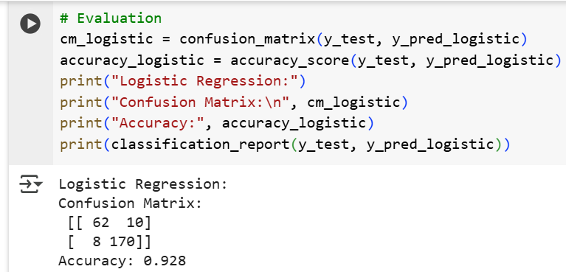
- True Negatives (TN): 62
- False Positives (FP): 10
- False Negatives (FN): 8
- True Positives (TP): 170
These values demonstrate that Logistic Regression was able to correctly classify the majority of students in both categories.

Selection of the Best-Fit Model
# Compare model performances
model_comparison = pd.DataFrame({
'Model': ['Logistic Regression', 'K-Nearest Neighbors', 'Naïve Bayes', 'Decision Tree'],
'Accuracy': [accuracy_logistic, accuracy_knn, accuracy_nb, accuracy_dt],
'Errors': [
cm_logistic[0,1] + cm_logistic[1,0],
cm_knn[0,1] + cm_knn[1,0],
cm_nb[0,1] + cm_nb[1,0],
cm_dt[0,1] + cm_dt[1,0]
]
})

print("\nModel Comparison:")
print(model_comparison)

# Identify the best model
best_model = model_comparison.loc[model_comparison['Accuracy'].idxmax()]
print("\nBest Model:")
print(best_model)

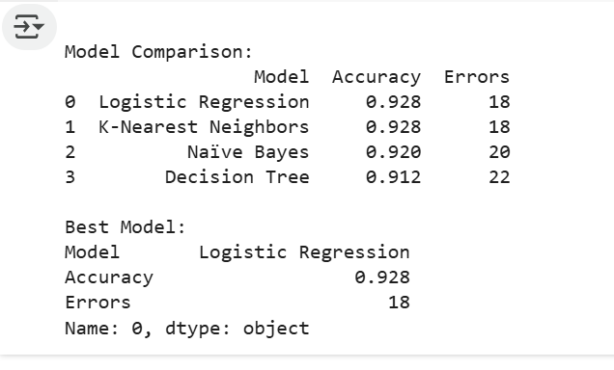
After comparing the outcomes, Logistic Regression was found to be the best-fit classifier. Although Naïve Bayes was slightly higher in cross-validation accuracy, Logistic Regression showed balanced performance across all the metrics like precision, recall, and F1-score. It also had low misclassification rates and provided reproducible performance on unseen data.

17- Predict the dependent variable by using best-fit classifier.
According to the results from Question 16, Logistic Regression was selected as the most suitable classifier for predicting whether a student passes or fails using their reading and writing scores.
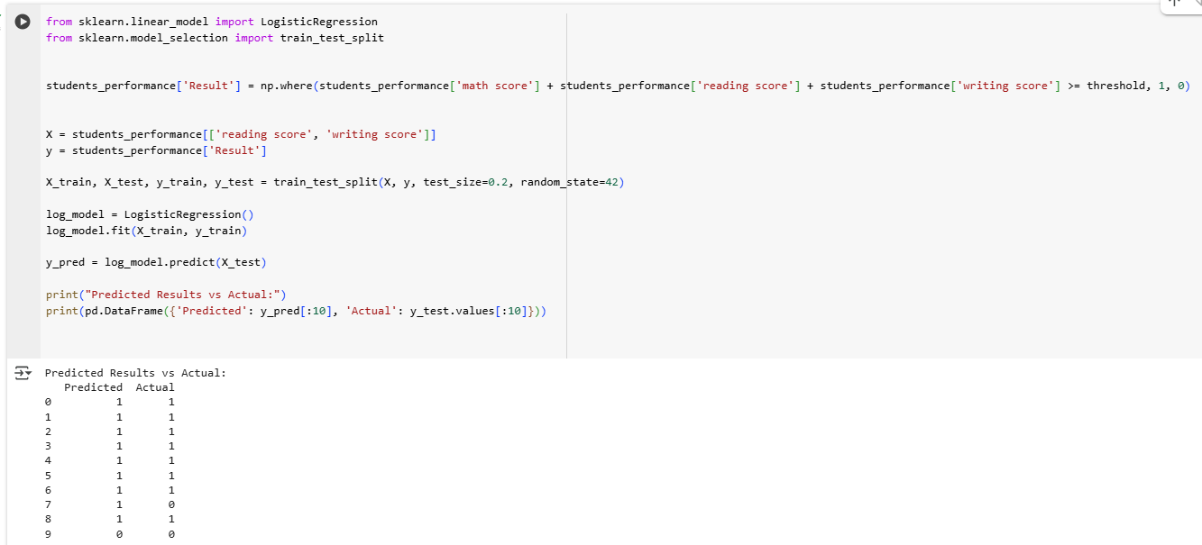

18- Perform the cluster analysis such as K-means and Horizontal for any field from the chosen dataset.
Part 1: k means
import numpy as np  import matplotlib.pyplot as plt  import pandas as pd  from sklearn.cluster import Kmeans  dataset =pd.read_csv('StudentsPerformance.csv')  X = dataset.iloc[:, [5, 6, 7]].values # math score, reading score, writing score  print(X)  wcss = []  for i in range(1, 11):  kmeans = KMeans(n_clusters=i, init='k-means++', random_state=1)  kmeans.fit(X)  wcss.append(kmeans.inertia_)  plt.plot(range(1, 11), wcss)  plt.title('The Elbow Method')  plt.xlabel('Number of clusters')  plt.ylabel('WCSS')  plt.grid(True)  plt.show()  kmeans = KMeans(n_clusters=3, init='k-means++', random_state=1)  y_kmeans = kmeans.fit_predict(X)  print(y_kmeans)  from sklearn.decomposition import PCA  pca = PCA(n_components=2)  X_pca = pca.fit_transform(X)  plt.scatter(X_pca[y_kmeans == 0, 0], X_pca[y_kmeans == 0, 1], s=100, c='red', label='Cluster 1')  plt.scatter(X_pca[y_kmeans == 1, 0], X_pca[y_kmeans == 1, 1], s=100, c='blue', label='Cluster 2')  plt.scatter(X_pca[y_kmeans == 2, 0], X_pca[y_kmeans == 2, 1], s=100, c='green', label='Cluster 3')  plt.scatter(kmeans.cluster_centers_[:,0], kmeans.cluster_centers_[:, 1], s=300, c='yellow', label='Centroids (raw)')  plt.title('Clusters of Students (PCA Projection)')  plt.xlabel('Principal Component 1')  plt.ylabel('Principal Component 2')  plt.legend()  plt.show() | 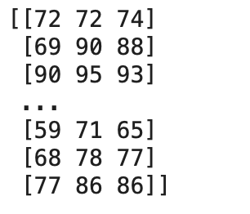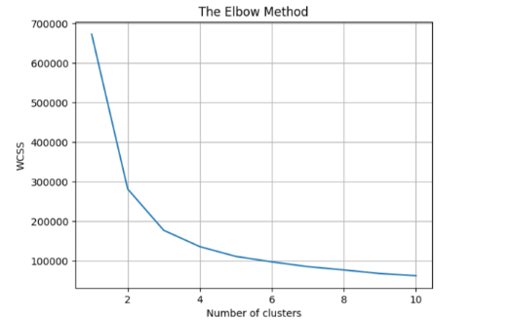  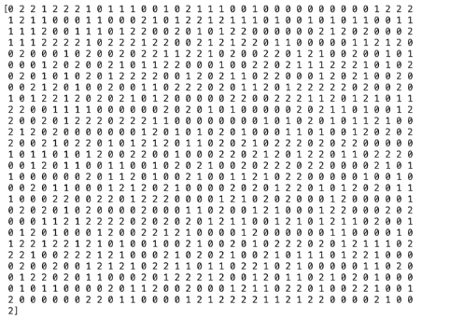  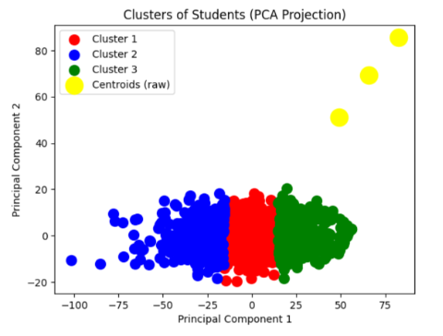
Part 2 : Horizonital
import numpy as np  import matplotlib.pyplot as plt  import pandas as pd  import scipy.cluster.hierarchy as sch  from sklearn.cluster importAgglomerativeClustering  from sklearn.decomposition import PCA  dataset = pd.read_csv('StudentsPerformance.csv')  X = dataset.iloc[:, [5, 6, 7]].values # math score, reading score, writing score  print(X)  dendrogram = sch.dendrogram(sch.linkage(X, method='ward'))  plt.title('Dendrogram')  plt.xlabel('Students')  plt.ylabel('Euclidean distances')  plt.grid(True)  plt.show()  hc = AgglomerativeClustering(n_clusters=3, metric='euclidean', linkage='ward')  y_hc = hc.fit_predict(X)  pca = PCA(n_components=2)  X_pca = pca.fit_transform(X)  plt.scatter(X_pca[y_hc == 0, 0], X_pca[y_hc == 0, 1], s=100, c='red', label='Cluster 1')  plt.scatter(X_pca[y_hc == 1, 0], X_pca[y_hc == 1, 1], s=100, c='blue', label='Cluster 2')  plt.scatter(X_pca[y_hc == 2, 0], X_pca[y_hc == 2, 1], s=100, c='green', label='Cluster 3')  plt.title('Hierarchical Clusters of Students (PCA Projection)')  plt.xlabel('Principal Component 1')  plt.ylabel('Principal Component 2')  plt.legend()  plt.show() | 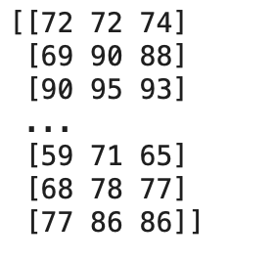  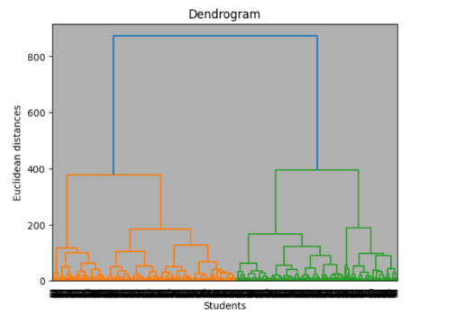  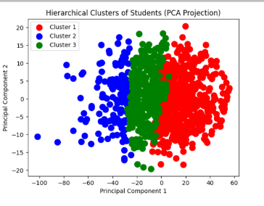

19- Explain the strategy for improving the system after viewing the cluster diagram.
Strategy for Improving the System After Viewing the Cluster Diagram
After analysing the cluster diagrams generated from the K-means and hierarchical clustering models, we can do the following solutions to improve the system and enhance students’ performance:
1. Targeted Interventions Based on Clusters
- Cluster 1 (Low Scores):
  - Issue: Students in this cluster may struggle across all subjects (math, reading, writing).
  - Solution: Provide additional tutoring, personalized learning plans, or one-on-one teacher time.
- Cluster 2 (Moderate Scores):
  - Issue: Students perform moderately but may lack consistency in certain subjects.
  - Solution: Focus on strengthening weaker areas (e.g., math) through workshops or peer study groups.
- Cluster 3 (High Scores):
  - Issue: High performers may not be sufficiently challenged.
  - Solution: Offer advanced coursework or enrichment programs to keep them engaged.
2. Resource Allocation
- Allocate more resources (teachers, materials) to clusters with lower performance.
- Use clustering insights to design tailored teaching methods (e.g., visual aids for math, interactive reading sessions).
3. Early Warning System
- Implement predictive analytics to flag at-risk students early based on cluster trends.
- Monitor progress and adjust strategies dynamically.
4. Parental and Community Engagement
- Share cluster-based insights with parents to support collaboration in addressing student needs.
- Organize community workshops for skill-building (e.g., test preparation).
5. Curriculum Adjustments
- Modify teaching strategies based on cluster patterns (e.g., more practice tests for writing if Cluster 2 struggles).
- Introduce collaborative projects to bridge gaps between subjects.
6. Continuous Feedback
- Regularly update clustering models with new data to improve strategies.
Clustering helps teachers move from teaching everyone the same way to using data to support each student according to their need which would lead to more improvements.

CLO 4 - Version Control
1. Create a new repo for project in Git Hub
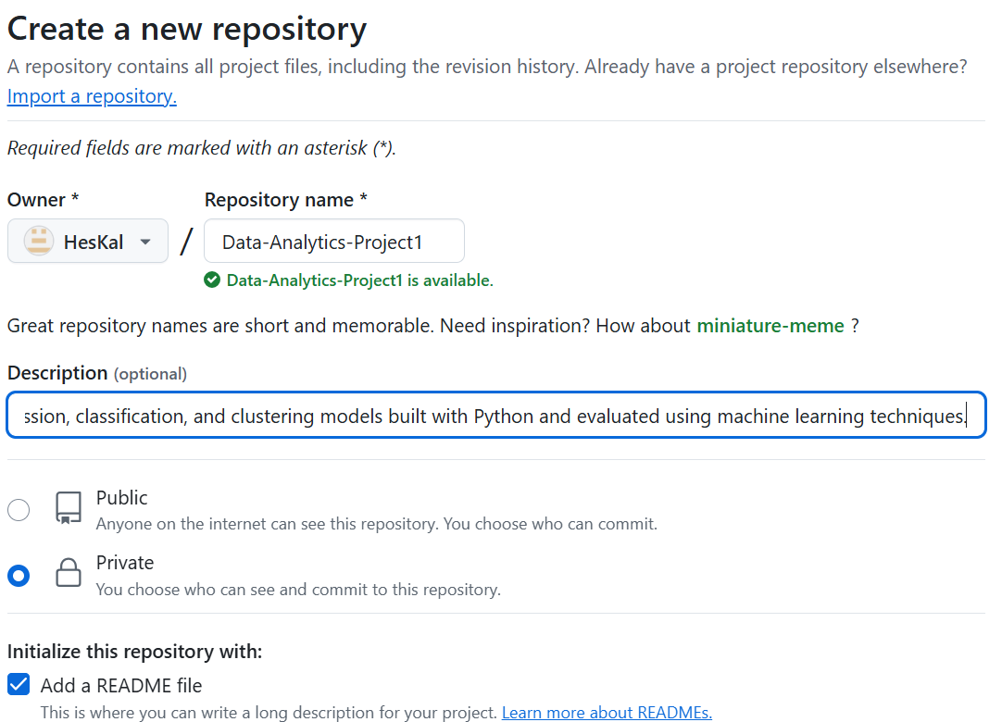

2. Upload all the project files created for CLO1, CLO2 and CLO3 to the Git Hub repo
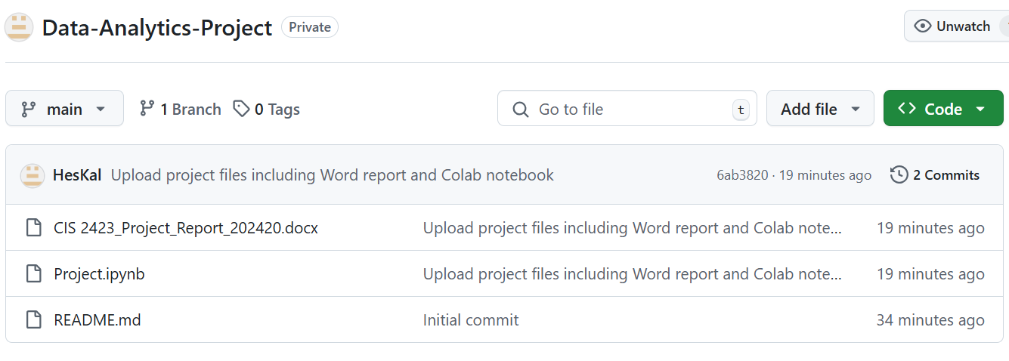
3. Configure Git with GitHub
4. Clone Git hub repo to Git
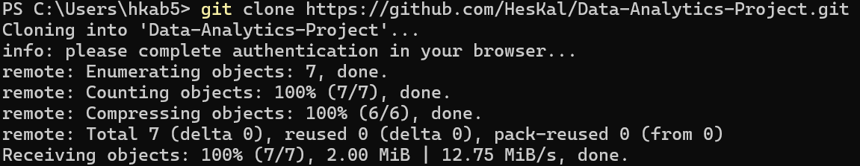
5. Pull any file from Git Hub repo to Git
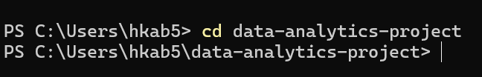
6. Modify the pulled file and push the modified file to Git Hub
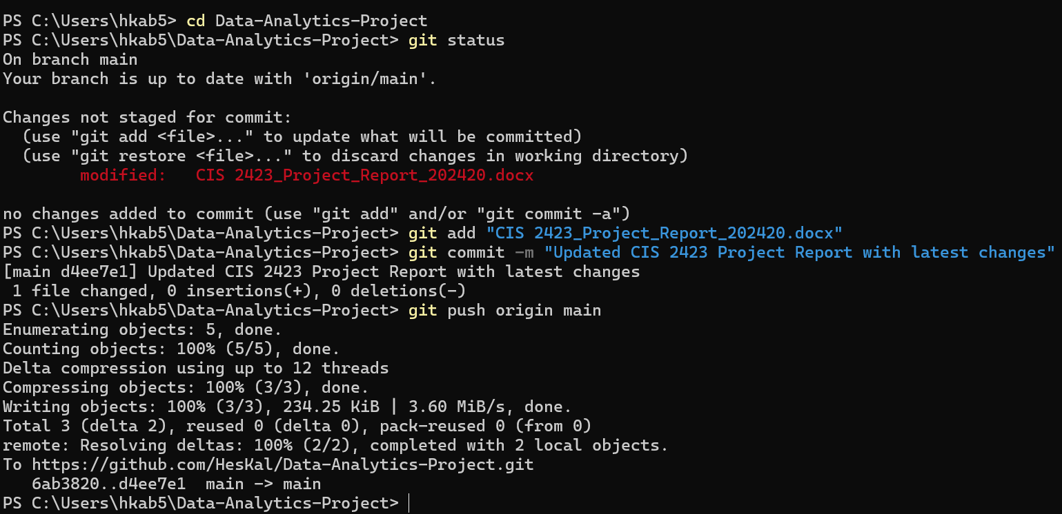
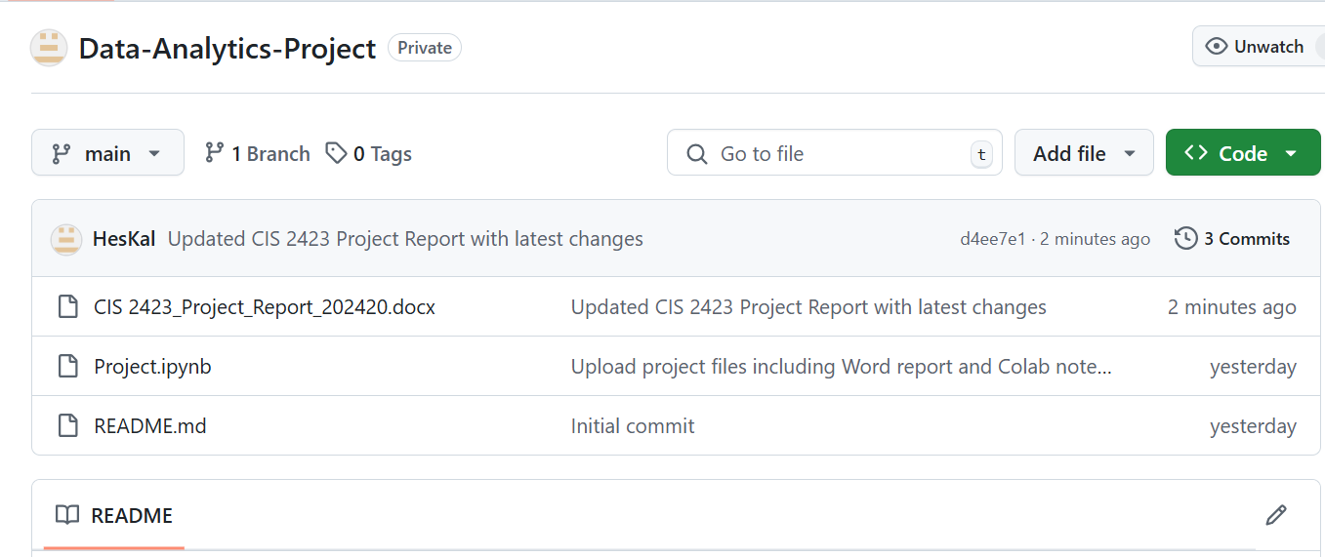

Rubric
Please note that the Project rubric should reflect the project description and be CAP-compliant. Please feel free to customize the descriptors as per the project requirements and course level.

Group Project Rubric [Task-specific RUBRIC]

 |  | Absent (F) | Insufficient (1-59%)  (F) | Emerging (60-69%)  (D/D+/C-) | Satisfactory (70-76%)  (C/C+) | Competent (77-86%)  (B-/B/B+) | Mastering (87-100%)  (A-/A)
- Group Grading-Critical Thinking: Analysis and Evaluation [45%] | Deliverable 1: understanding of data analytics [CLO1]  (5%) |  | None of the following:  - Purpose of data analysis not mentioned.  - Selection of programming language is not referenced.  - Type of machine learning algorithm to be analyzed is not defined  - Variables for data analysis are not mentioned  . | Some but not all the following:  - Purpose of data analysis mentioned but not clear.  - Selection of programming language is referenced.  - Required machine learning algorithm to be analyzed is ill-defined [Too many models mentioned]  - Variables for data analysis are mentioned without justification | Most but not all the following:  - Purpose of data analysis is clearly mentioned.  - Selection of programming language is referenced.  - Required machine learning algorithm to be analyzed is defined, but without justification.  - Variables for data analysis are mentioned with justification but not clear | All of the following:  - Purpose of data analysis is clearly mentioned.  - Sound rationale for choosing the programming language  - Required machine learning algorithm to be analyzed is well-defined with appropriate justification.  - Variables for data analysis are mentioned with clear justification | All of the following:  - Purpose of data analysis is clearly mentioned with appropriate explanation  - Thoroughness of programming language chosen is evident.  - Student synthesizes information about machine learning algorithm from multiple disciplines and sources and presents them with clarity.  - Variables for data analysis are precisely defined with appropriate justification  - Employ outstanding knowledge about the data analysis from different sources
 | Deliverable 2: Apply data analysis and visualization techniques [CLO2]  (25%) |  | - No evidence of justification to perform descriptive statistics  - Function is not created for descriptive statistics  - Sampling techniques are not designed  - Exploratory analysis are not performed  - Hypothesis tastings are not achieved  - Data preprocessing is not devised  - Regression models are not functioned  - Optimization for regression model is not operated  - Best fit model is not enacted | Some but not all the following:  - Evidence of justification to perform descriptive statistics exist but not clear  - Function is created for descriptive statistics having major syntactical errors.  - Sampling techniques are designed but not appropriate  - Exploratory analysis are performed but ill-designed  - Hypothesis tastings are achieved with flaw  - Evidence for data preprocessing exist but with inappropriate techniques  - Regression models are functioned with huge faults  - Optimization for regression model is operated with inaccuracies  Best fit model is enacted without justification. | Most but not all the following:  - Evidence of justification to perform descriptive statistics exist with clear elucidation  - Function is created for descriptive statistics without flaws.  - Sampling techniques are designed with appropriate rationalization  - Exploratory analysis are performed with appropriate legends  - Hypothesis tastings are achieved appropriate assumption  - Evidence for data preprocessing exist but with applicable techniques  - Regression models are functioned without mistake  - Optimization for regression model is operated with appropriate metrics  - Best fit model is enacted appropriate interpretation | All of the following:  - Appropriate description and exploratory analysis provided.  - Sound rationale for chosen hypothesis testing  - High accuracy obtained for regression model  - Rigor is evident. | All of the following:  - Appropriate description and exploratory analysis provided along with exemplary analysis  - Sound rationale for chosen hypothesis testing and infer statically in commendable way  - Other regression model are handled obtained from different sources  - Rigor is evident.
 | Deliverable 3: The data model created using classification and clustering algorithm of machine learning [CLO2, CLO3]  (15%) |  | - Incomplete classification models are presented.  - No optimization and recommendation are performed for classification model.  - No evidence of any cluster analysis  - No strategies are produced from cluster model. | Some but not all the following:  - Comprehensive classification models are presented but with significant errors  - Thorough optimization and recommendation are performed for classification model but with poor validation  - Evidence of cluster analysis exists with poor performance  - Strategies are derived from cluster model which are insignificant | Most but not all the following:  - Comprehensive flawless classification models are presented  - Thorough optimization and recommendation are performed with appropriate validation for classification model  - Evidence of cluster analysis exists with better performance  - Strategies are derived from cluster model which are significant but not consistent | All of the following:  - Implemented all classification models  - Major validation works demonstrated on optimization and recommendation of classification model  - Appropriate cluster analysis was performed and good strategies are postulated and well-documented. | All of the following:  - All classification models are accurate  - Perform more classification models from different sources  - All cluster models are accurate  - Perform more cluster models from different sources  - Appropriate interpretation and recommendations are provided
 | Deliverable 4: Data Versioning  [CLO 4]  (5%) |  | - No evidence of creating a new repository and uploading project files to Git Hub  - Git is not configured with Git Hub  - No evidence for cloning Git hub repo to Git  - Push and Pull are not performed | Some but not all the following:  - Repository model is created but files are not uploaded to repo  - Git is not configured with Git Hub  - Evidence of cloning exists with appropriate options  - Push and Pull are performed which are insignificant | Most but not all the following:  - Repo are created and project files are uploaded to repo  - Git configuration are performed with accordance of Git Hub  - Evidence of cloning exists with proper options  - Push and Pull are significant but not consistent | All of the following:  - Repo are created and project files are uploaded  - Advanced configuration is performed on Git  - Many functions related to cloning is performed apart from basic operations  - Push and pull with different scenario are mentioned | All of the following:  - Scenario is created and explained about significance of repo creation  - Advanced configuration is performed on Git  - Different cloning techniques should be elucidated.  - Push and pull with different scenario are mentioned  - Branching should be exhibited
Group Grading:  Report Quality [5%] |  |  | - Incomplete report with missing most of the deliverable components.  - Too many typographical errors. | Some but not all of the following:  - Complete report with required deliverables.  - Clear table of contents showing all required sections.  - Free from formatting and typographical errors. | Most but not all of the following:  - Complete report with all required format and deliverables.  - Some minor formatting and/or typographical errors.  - Table of contents presented with some missing information. | All of the following:  - Complete report with required format and deliverables.  - Clear table of contents showing all required sections.  - Some minor formatting and/or typographical errors. | All of the following:  - Complete report with required format and deliverables.  - Clear table of contents showing all required sections.  - Free from formatting and typographical errors.

Individual Oral Presentation

Student (1) Name: ____________________________ Student HCT ID:_______________
 | Absent | 1-59.49% | 59.5% - 69.49% | 69.5% - 76.49% | 76.5% à86.49% | 86.5% à100%
Collaboration (10%) |  | - Does not partake in the task or is so frequently distracted that he/she produces.  - Having made no contribution to the group's objective. | - Participates in the task but does not collaborate with others or contribute to the group process.  - Participates in discussions.  - Expresses own opinion and viewpoints.  - Remains dedicated to the subject.  - Performs independently specific tasks | - Cooperates with the group process, but does not coordinate contributions with those of others.  - Does not interrupt while listening.  - Actively seeks the input of others.  - Accepts duties that have been assigned.  - Complies with the group consensus.  - Utilizes the ideas of others | - Coordinates processes and products with those of teammates, but does not resolve significant conflicts.  - Actively pays attention to what is being said.  - Offers and accepts constructive feedback.  - Adapts ideas and/or processes to the needs of colleagues.  - Seeks consensus.  - Effectively resolves trivial disputes | - Student coordinates collaborative processes and outputs.  - Effectively resolves both significant and minor conflicts.  - Expresses disagreements in an open and diplomatic manner.  - Supports group decisions even if they are not unanimously supported.  - Compromised and negotiated to attain an agreement
Oral Communication (Presentation)  (12 Marks) [All CLOs] |  | - Communicates with a limited sense of audience and purpose  - No eye contact, no body language, and no decorum  - Communicates with limited clarity  - Uses language with limited accuracy and effectiveness.  - Tension and anxiety are palpable;  - Has difficulty recovering from errors. | Not all of the foregoing are true:  - Communicates with a clear sense of audience and purpose  - Eye contact, body language, and decorum)  - Communicates information and ideas with considerable clarity  - Uses language with considerable accuracy and efficacy  - Makes insignificant errors, but rapidly recovers  - Displays minimal or no tension. | Most of the following, but not all:  - Communicates with a clear sense of audience and purpose  - Eye contact, body language, and decorum)  - Communicates information and ideas with substantial clarity  - Uses language with substantial accuracy and effectiveness.  - Makes simple mistakes but recovers swiftly;  - Displays minimal or no tension. | Each of the subsequent:  - Communicates with a clear sense of audience and purpose  - Eye contact, body language, and decorum  - Communicates information and ideas with considerable clarity  - Uses language with considerable accuracy and efficacy.  - Makes insignificant errors, but recovers rapidly  - Demonstrates minimal or no tension. | Each of the subsequent:  - Communicates with a strong awareness of audience and purpose  - Maintains audience's attention by using direct eye contact and rarely glancing at notes.  - Communicates information and ideas with a high degree of precision and precision  - Student appears at ease and confident, with no errors.
Follow-up questions and discussion (28 Marks) [All CLOs] |  | Unable to answer questions from the examining board | Able to answer some but not all questions from the examining board | Able to answer most but not all questions from the examining board | Capable of answering all of the examining board's queries. | Capable of responding to all inquiries and demonstrating a thorough understanding of the material.

